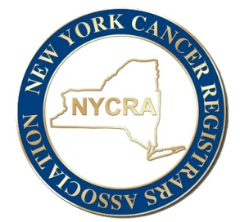
NYCRA
Organization Advertisement Application
NYCRA offers advertisement opportunities for organizations on our website for a fee of $350.00. NYCRA will advertise for an organization for 3 months. NYCRA will place the company logo on our home page. The logo will be hyperlinked to the organization’s website or area they would like to advertise.
Please complete the following and return via email to newyorkcancerregistrarsassoc@gmail.com
Payment made via check; Made payable to NYCRA
Mailed to: Tarah Hoogkamp
63 Vosburgh Trailer Park
Mechanicville NY 12118.

Organization:

Hyperlink/ website:

Contact Name:

Contact Email:

